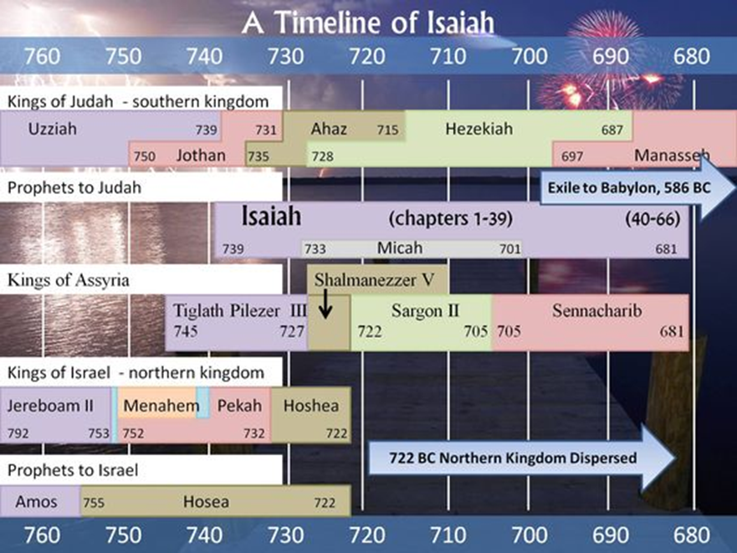

https://www.pinterest.at/pin/167759154845024141/

