Isaiah

The Revelation within Isaiah

Chapters 16, 17

In Chapters 16 and 17 of Isaiah, we continue with the prophecies Isaiah sees and receives regarding the countries surrounding Judah. Because Isaiah has access to the royal court of the King of Judah, he is aware and an advisor most likely to Judah’s foreign policies, considerations, and internal musings by the king and his council. This prophet continuously entreats the people of God to trust in God alone, not to their workings and alliances with other nations.

During the reigns of King Ahaz and King Hezekiah, there was much transition in the middle east in regards to national power and diplomacy. Judah was asked to join forces with neighboring nations, and was considering to ask others to ally with them. Chapters 13-23 is the revelations God gave Isaiah regarding all the nations surrounding Judah at the time and their impending future. It’s as if Isaiah is seeing a huge map of the region, and as he looks upon one nation God prophesies through him about that nation. Then he looks at another nation on the map, then another, etc. When you read theses chapters in whole, it may have been how Isaiah received these prophesies.

As we discussed earlier, some of these prophesies about certain nations didn’t come about until 250years later. Some happened within 3 years, some are still to occur in our times or the future. The accuracy of the fulfilled prophecy in these chapters endorses the surety of God’s Word for the future. God imagines it and it comes to pass exactly as He said it would.

Maps of the Region:

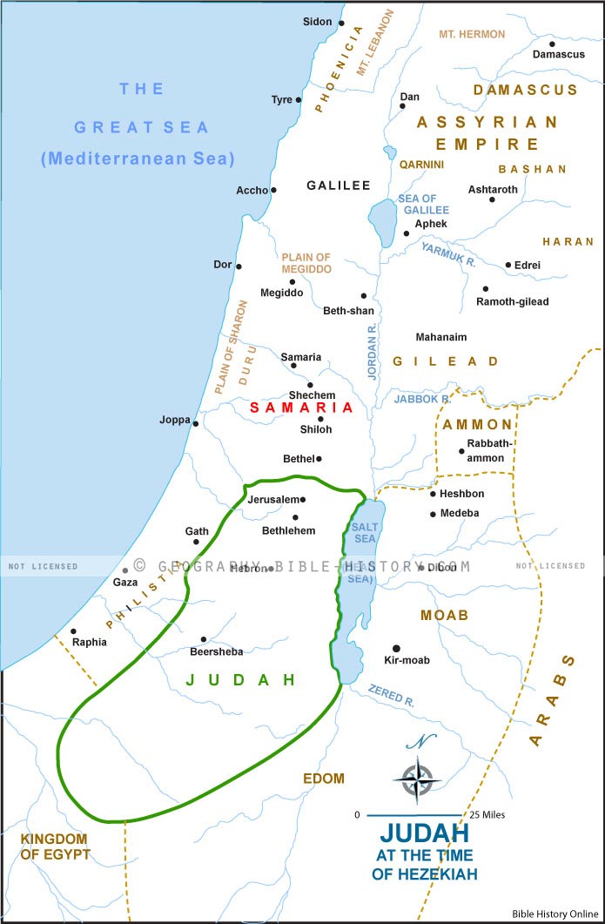

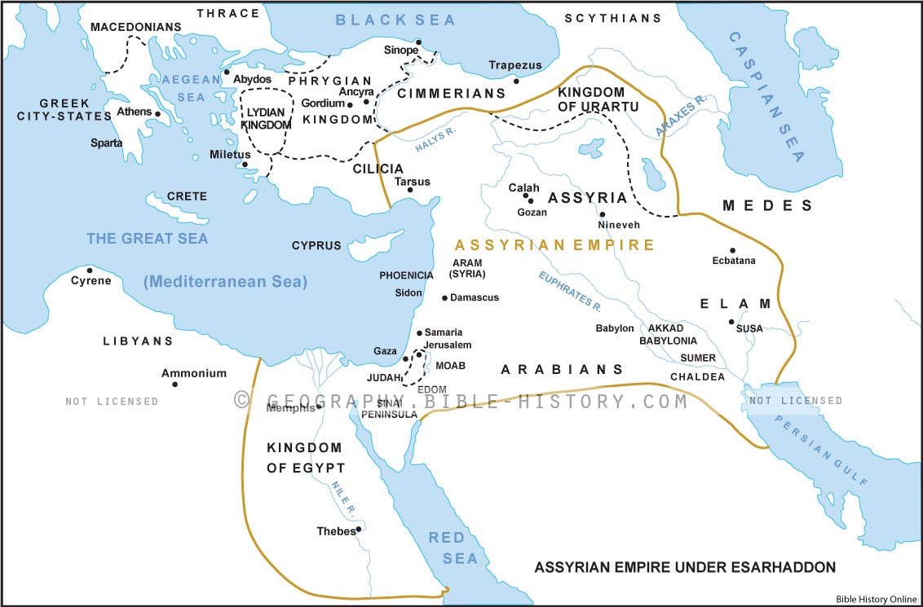

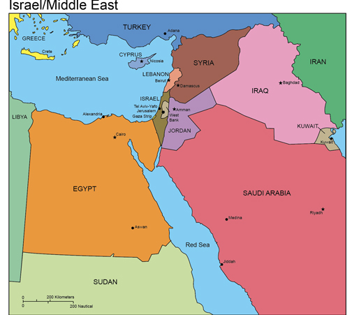

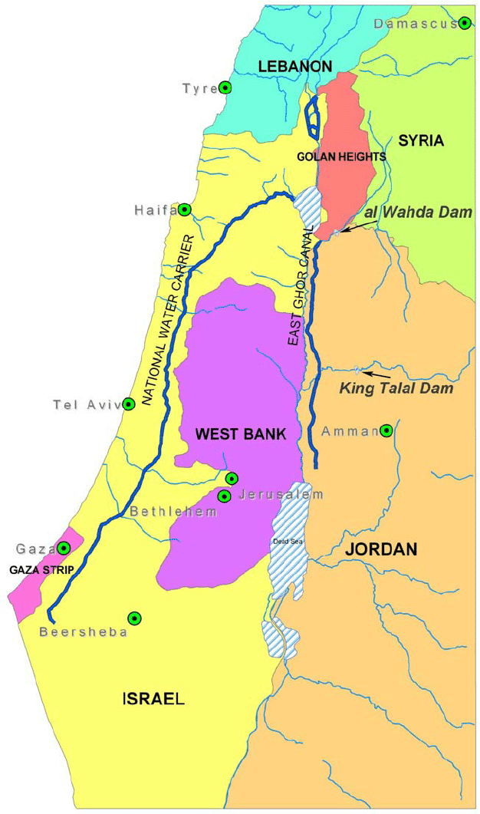

Read Isaiah 16 and 17 in the New King James Version.

Chapters 16, 17 The Passion Translation:

16 Send a flock of lambs from the rock of the desert

as a gift to the leaders in Jerusalem,
to the mountain of the Daughter of Zion.
² At the banks of the River Arnon, the women of Moab
are like newly hatched, fluttering birds.
³ They say, “Make a decision!
Give us shelter. Hide the fugitives. Don’t betray them!
⁴ Allow the Moabite fugitives to stay with you.
Be a shelter for them from the destroyer!”
One day the oppressor will be no more.
The destroyer will come to an end,
and the tyrant will vanish from the land.
⁵ Then a government of unfailing love will be established,
with a faithful king in the tabernacle of David,
passionate for justice and swift to do what is right.

Moab’s Demise

⁶ We have heard about Moab’s pride.
How haughty he is—filled with arrogance and insolence,
with nothing more than empty boasts!
⁷ So now Moab will wail;
everyone will wail over the ruin of their country.
Lament and grieve for the foundations of Kir-Hareseth.
⁸ All the lush fields of Heshbon are dried up.
The vineyards of Sibmah have struck down the lords of nations,
whose vines reached northward to Jazer
and spread to the desert.
Their shoots spread out and extend across the Dead Sea.
⁹ So I weep along with Jazer over the vines of Sibmah.
I drench you with my tears, O Heshbon and Elealeh,
for the shouts of joy over the harvest
of fruit and grain have ceased.
¹⁰ Joyful celebrations are stilled in the orchards;
in the vineyards, no one sings or shouts,
and no one treads out wine in the presses.
I have silenced your gleeful shouts.
¹¹ Like harp strings, my heartstrings throb for Moab,
and my inner being sighs for your broken walls, Kir-Hareseth.
¹² When Moab comes to their high places
to plead with all their might
and enter their temples to pray, it will have no effect.

¹³ This was the word the Lord Yahweh spoke in the past about Moab, ¹⁴ but now the Lord Yahweh says, “In exactly three years, the splendor of Moab and its huge population will shrink to nothing; only a small and feeble remnant will remain.”

A Prophecy about Damascus

17 This is God’s message for Damascus:

“Behold, Damascus is gone!
It is no longer a city, only a heap of rubble.
² Her ruins will be abandoned—
left for flocks to lie down in with nothing to fear.
³ Damascus will lose the power of its fortress,
and the strongholds of the northern kingdom will disappear.
The remnant of Syria will be like Israel—stripped of its glory,”
says the Lord Yahweh, Commander of Angel Armies.
⁴ “On that day, the beautiful splendor of Jacob’s northern tribes
will be brought low, and they will become like skin and bones.
⁵ It will be as when a farmer harvests the standing grain
and gathers armloads of grain,
and as one gathers ears of grain in the Valley of Giants.
⁶ Yet some gleanings will remain,
as when an olive tree is shaken,
leaving two or three olives in the highest branches
and four or five on its fruitful branches,”
declares Lord Yahweh, the God of Israel.
⁷ In that day, people will gaze toward their Creator,
and their eyes will look in faith toward the Holy One of Israel.
⁸ They will not be infatuated with the religious altars
their own hands crafted,
nor by what their own fingers have made,
nor with their sacred groves or altars of incense.
⁹ On that day their bustling cities will become deserted
like those conquered by the Israelites—
abandoned to thickets and undergrowth,
it will all become desolate.
¹⁰ For you have ignored and forgotten the God who saves you
and have not remembered your Rock of Safety.
So what do you do?
You cultivate your beautiful gardens and plant imported vines.
¹¹ Even if on the day you plant them they begin to grow,
and even if immediately you see them bud,
your harvest will wither away in a day of grief and agony.

The Uproar of the Nations

¹² Ah, the thunder of many people joining together!
They roar like the roar of the sea.
Woe to the uproar of the many nations!
They thunder like the crashing of ocean waves.
¹³ The nations are roaring like the roar of a massive waterfall,
but when God rebukes them they disperse
like chaff on the mountains,
like a tumbleweed whirling in the wind.
¹⁴ In the evening—behold, sudden terror!
Before the morning comes, they vanish!
Such is the fate of those who plunder and try to rob us.

Notes with the New King James Version:

Moab Destroyed

16 Send the lamb to the ruler of the land,
From Sela to the wilderness,
To the mount of the daughter of Zion.
² For it shall be as a wandering bird thrown out of the nest;
So shall be the daughters of Moab at the fords of the Arnon.
- King of Moab, Mesha already paid tribute to King Ahaz. As King Mesha sent 100,000 lambs each year to King Ahab of Israel (2 Kin 3:4), so now the Moabites are advised to win the king’s favor and protection by diverting their tribute to the king in Jerusalem as an acknowledgment of subjection. -Amplified Bible, footnotes

³ “Take counsel, execute judgment;
Make your shadow like the night in the middle of the day;
Hide the outcasts,
Do not betray him who escapes.
⁴ Let My outcasts dwell with you, O Moab;
Be a shelter to them from the face of the spoiler.
For the extortioner is at an end,
Devastation ceases,
The oppressors are consumed out of the land.
⁵ In mercy the throne will be established;
And One will sit on it in truth, in the tabernacle of David,
Judging and seeking justice and hastening righteousness.”

⁶ We have heard of the pride of Moab—
He is very proud—
Of his haughtiness and his pride and his wrath;
But his lies shall not be so.
- These judgements on the surrounding nations, and upon Judah and Israel themselves, revolves around this one error. Pride. The haughtiness of man and their nation was their ultimate ruin sooner or later.
⁷ Therefore Moab shall wail for Moab;
Everyone shall wail.
For the foundations of Kir Hareseth you shall mourn;
Surely they are stricken.

⁸ For the fields of Heshbon languish,
And the vine of Sibmah;
The lords of the nations have broken down its choice plants,
Which have reached to Jazer
And wandered through the wilderness.
Her branches are stretched out,
They are gone over the sea.
- Invading nations often cut down the fruit frees and vineyards of the nations they attacked. At times, they also poisoned water supplies to prohibit their enemies from living and thriving in their homelands. Such was the Assyrian assault on Moab that certainly involved the destruction of vineyards. – The Perry Stone Hebraic Prophetic Study Bible footnotes, p. 1055

⁹ Therefore I will bewail the vine of Sibmah,
With the weeping of Jazer;
I will drench you with my tears,
O Heshbon and Elealeh;
For battle cries have fallen
Over your summer fruits and your harvest.
- Again we see the compassion the prophet Isaiah had for this condemning prophesy over the Moabite people.

¹⁰ Gladness is taken away,
And joy from the plentiful field;
In the vineyards there will be no singing,
Nor will there be shouting;
No treaders will tread out wine in the presses;
I have made their shouting cease.
¹¹ Therefore my heart shall resound like a harp for Moab,
And my inner being for Kir Heres.
-Even for pride-filled Moab, God’s heart was moved with compassion. - TPT footnotes

¹² And it shall come to pass,
When it is seen that Moab is weary on the high place,
That he will come to his sanctuary to pray;
But he will not prevail.

¹³ This is the word which the Lord has spoken concerning Moab since that time. ¹⁴ But now the Lord has spoken, saying, “Within three years, as the years of a hired man, the glory of Moab will be despised with all that great multitude, and the remnant will be very small and feeble.”
- This is an often-overlooked and time-specific prophecy declaring that within three years, the words would fulfilled. According to scholars, three years later the Assyrians scattered the ten tribes of Israel and invaded Moab, fulfilling Isaiah’s predictions. – The Perry Stone Hebraic Prophetic Study Bible footnotes, p. 1055

FULFILLED: This prophecy was fulfilled after the death of King Ahaz of Judah (Is 14:28), about the third year of King Hezekiah’s reign. Moab was not left completely without population at this time; there was still a “remnant.” The final desolation of Moab was reserved for King Nebuchadnezzar of Babylon in 582 b.c., some five years after the taking of Jerusalem. The ruins of Elealeh, Heshbon, Medeba, Dimon, etc., still exist to confirm through modern research the accuracy of the fulfillment of this prophecy. -Amplified Bible, footnotes

Proclamation Against Syria and Israel

17 The burden against Damascus.

“Behold, Damascus will cease from being a city,
And it will be a ruinous heap.

- Damascus, a city established because of its desert oasis, is the oldest city in the known world, dating back to the time of its first settlement in the second millennium BC. The city is mentioned as far back as the time of Abraham and identified as the home of his servant Eliezar (see Gen 15:2). Damascus was the capital of ancient Syria and remains the capital of modern day Syria. Throughout history, Damascus has been involved in various ways in wars and conflicts, however, it has never been completely destroyed at any point in its four-thousand-year history. We do know that its vineyards and orchards were destroyed. But the city itself was spared, as it would pay tribute to surrounding kings of the nations who occupied it at various times. Prophetic scholars have noted that Damascus has never been destroyed, and many believe its prophesied demise will be fulfilled in a future war with Israel. It is interesting that Damascus and Syria are not mentioned in the famed war of Gog and Magog (see Ezek 38-39) and not mentioned in the time of the Tribulation as other nations, such as Egypt, Libya, and Ethiopia (see Dan 11:43) Modern-day Damascus has six million individuals living in the region. Since 1948, the city of Damascus and the nation of Syria have been enemies of Israel and have engaged Israel in four major wars: 1948, 1967, 1973, and 1982. Some scholars believe that Damascus will engage Israel in a future war, perhaps using chemical weapons, which will cause Israel to retaliate and destroy this ancient city. – The Perry Stone Hebraic Prophetic Study Bible footnotes, p. 1056

- Since the Syrian Civil War, Damascus has taken on major damage. The newest Battle of Damascus began in July 15, 2012 to May 21, 2018. (5 years, 10 months and 6 days)

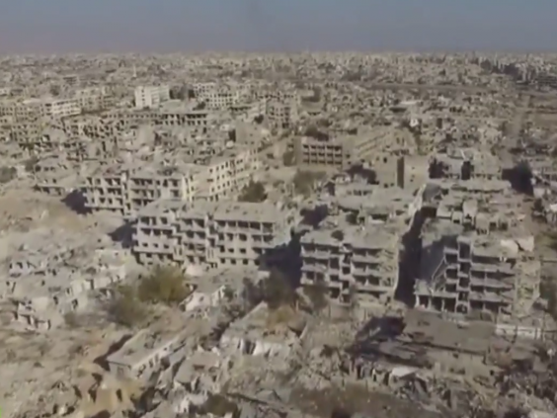

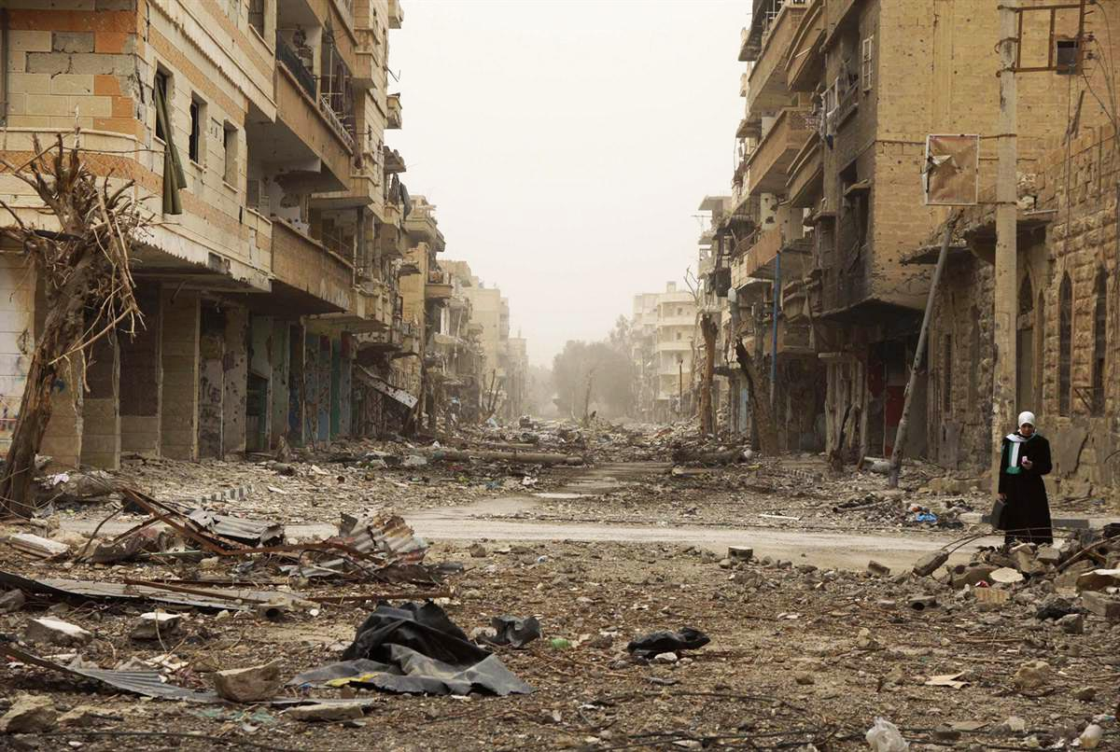
² The cities of Aroer are forsaken;
They will be for flocks
Which lie down, and no one will make them afraid.
³ The fortress also will cease from Ephraim,
The kingdom from Damascus,
And the remnant of Syria;
They will be as the glory of the children of Israel,”
Says the Lord of hosts.

⁴ “In that day it shall come to pass
That the glory of Jacob will wane,
And the fatness of his flesh grow lean.
⁵ It shall be as when the harvester gathers the grain,
And reaps the heads with his arm;
It shall be as he who gathers heads of grain
In the Valley of Rephaim.
⁶ Yet gleaning grapes will be left in it,
Like the shaking of an olive tree,
Two or three olives at the top of the uppermost bough,
Four or five in its most fruitful branches,”
Says the Lord God of Israel.

⁷ In that day a man will look to his Maker,
And his eyes will have respect for the Holy One of Israel.
⁸ He will not look to the altars,
The work of his hands;
He will not respect what his fingers have made,
Nor the wooden images nor the incense altars.
⁹ In that day his strong cities will be as a forsaken bough
And an uppermost branch,
Which they left because of the children of Israel;
And there will be desolation.

¹⁰ Because you have forgotten the God of your salvation,
And have not been mindful of the Rock of your stronghold,
Therefore you will plant pleasant plants
And set out foreign seedlings;
¹¹ In the day you will make your plant to grow,
And in the morning you will make your seed to flourish;
But the harvest will be a heap of ruins
In the day of grief and desperate sorrow.
- This prediction, interestingly enough, includes Israel, (northern kingdom) because by this time Israel and Syria were so closely tied together in their own treaty that you could virtually treat them as one. It is predicted that only a tiny fragment of each will be left, and again it came true. – Pawson, Come With Me Through Isaiah, p.96

Isaiah 7:1-2
v. 7 Syria, or the Gentiles, unbelievers, heathens, forgot their Maker.
v. 10 Israel, the children of God, forgot their God of salvation

¹² Woe to the multitude of many people
Who make a noise like the roar of the seas,
And to the rushing of nations
That make a rushing like the rushing of mighty waters!
¹³ The nations will rush like the rushing of many waters;
But God will rebuke them and they will flee far away,
And be chased like the chaff of the mountains before the wind,
Like a rolling thing before the whirlwind.
¹⁴ Then behold, at eventide, trouble!
And before the morning, he is no more.
This is the portion of those who plunder us,
And the lot of those who rob us.
- Remember the miracoulos defeat of the Assyrian army when at the doorstep of Jerusalem they were slain in the night by a plague sent by the Lord God.
- The fulfillment of this prophecy is found in Isaiah 37:36, following the repetition of the prophecy first recorded in 2 Kin 19:29-36. Just when an overwhelming victory by the Assyrian Sennacherib seemed inevitable, during a single night 185,000 of his army died, and Judah was spared—as the Lord through Isaiah had promised. -Amplified Bible, footnotes

