Isaiah

The Revelation within Isaiah
Chapters 12, 13

Chapter 12 NKJV
A Hymn of Praise
Redemption is God’s last word, not judgment.
A song of praise to God because He is no longer angry and men are no longer afraid.

1 And in that day you will say:
“O Lord, I will praise You;
Though You were angry with me,
Your anger is turned away, and You comfort me.
2 Behold, God is my salvation,
I will trust and not be afraid;
‘For Yah, the Lord, is my strength and song;
He also has become my salvation.’ ” [Exodus 15:2; Psalm 118:14; Isaiah 53; Romans 10:7-13]
3 Therefore with joy you will draw water
From the wells of salvation. [Streams of salvation: Christ in us: Isa. 41:17-18; Jer. 2:13; 17:13; John 4:13-14; Rev. 7:17]

“This verse ( Isaiah 12:3) was quoted in the time of the Second Temple during the water libation service during the Feast of Tabernacles (when the Jews celebrate when they remember how God brought them through the wilderness and Moses rod struck the rock for water to gush forth), when the high priest carried water in a golden vessel from the pool of Siloam to the brass altar. Pouring the water on the altar, he would say, “With joy we draw water from the wells of salvation.” This pouring of the water was a picture and prediction of the promised outpouring of the Spirit (Joel 2:28-29; Acts 2). In this setting, on the last day of the Feast of Tabernacles, as the high priest was pouring water at the base of the brass altar, Christ cried out that if anyone was thirsty they should come to Him and drink. Christ added, “Out of his belly shall flow rivers of living water.” Christ was referring to the coming of the Holy Spirit, which was foreshadowed in the action of the priest pouring the water on the altar (John 7:37-39).” Perry Stone OT Hebraic Study Bible, p. 1051

4 And in that day you will say:
“Praise the Lord, call upon His name;
Declare His deeds among the peoples,
Make mention that His name is exalted.
5 Sing to the Lord,
For He has done excellent things;
This is known in all the earth.
6 Cry out and shout, O inhabitant of Zion,
For great is the Holy One of Israel in your midst!” [Psalm 47:1; Psalm 148-150]

High Praise to God for JESUS – the BRANCH – the BANNER – the ANOINTED ONE
Isaiah 11:9-10 NKJV
9They shall not hurt nor destroy in all My holy mountain,
For the earth shall be full of the knowledge of the Lord
As the waters cover the sea.
10 “And in that day there shall be a Root of Jesse,
Who shall stand as a banner (pole, flag, ensign) to the people;
For the Gentiles shall seek Him,
And His resting place shall be glorious.”

Isaiah 11:12 NKJV
12 He will set up a banner (pole, flag, ensign) for the nations,
And will assemble the outcasts of Israel,
And gather together the dispersed of Judah
From the four corners of the earth.”

John 11:32 NKJV
“32 And I, if I am lifted up from the earth, will draw all peoples to Myself.”

Ephesians 2:13-22 NKJV
“14 For He Himself is our peace, who has made both one, and has broken down the middle wall of separation, 15 having abolished in His flesh the enmity, that is, the law of commandments contained in ordinances, so as to create in Himself one new man from the two, thus making peace, 16 and that He might reconcile them both to God in one body through the cross, thereby putting to death the enmity. 17 And He came and preached peace to you who were afar off and to those who were near. 18 For through Him we both have access by one Spirit to the Father.
Christ Our Cornerstone
19 Now, therefore, you are no longer strangers and foreigners, but fellow citizens with the saints and members of the household of God, 20 having been built on the foundation of the apostles and prophets, Jesus Christ Himself being the chief cornerstone, 21 in whom the whole building, being fitted together, grows into a holy temple in the Lord, 22 in whom you also are being built together for a dwelling place of God in the Spirit.”

“These chapters (Isaiah 11, 12) are to build up your hope for the future, to look forward to the day when the Branch from the root and stump of Jesse will bring justice, will bring reconciliation to nature, will bring the Jews and the Gentiles gathered together around one banner, one flag, Jesus the ensign to the nations – and we shall all shout and sing praises to our God in all the earth, declaring what wondrous things He has done.” Come with Me through Isaiah, David Pawson, p. 88

Chapter 12 TPT
Song of Praise for the Redeemed

1 In that day you will sing,
“I praise you, Lord Yahweh,
for even though you were angry with me,
your anger turned away,
and now you tenderly comfort me.
2 Behold—God is my salvation!
I am confident, unafraid, and I will trust in you.”
Yes! The Lord Yah is my might and my melody;
he has become my salvation!
3 With triumphant joy you will drink deeply
from the wells of salvation.
4 In that glorious day, you will say to one another,
“Give thanks to the Lord and ask him for more!
Tell the world about all that he does!
Let them know how magnificent he is!”
5 Sing praises to the Lord, for he has done marvelous wonders,
and let his fame be known throughout the earth!
6 Give out a shout of cheer;
sing for joy, O people of Zion,
for great and mighty is the Holy One of Israel
who lives among you!

Isaiah Chapters 13-22 contains prophecies against nations.

Babylon: Isaiah 13:1-14:23
Assyria: Isaiah 14:24-27
Philistia: Isaiah 14:28-32
Moab: Isaiah 15:1-16:14
Syria: Isaiah 17:1-14
Ethiopia: Isaiah 18:1-7
Egypt: Isaiah 19:1-20:6
Babylon: Isaiah 21:1-10
Edom: Isaiah 21:11-12
Arabia: Isaiah 21:13-17
Jerusalem: Isaiah 22:1-25
Tyre: Isaiah 23:1-18

Chapter 13 NKJV
Proclamation Against Babylon

Babylon: Babel: means confusion and points to the political and religious confusion and disorder among the nations. This prophecy against Babylon was spoken by Isaiah at least 174+ years before Babylon fell in 539 BC.

1The burden against Babylon which Isaiah the son of Amoz saw.
2 “Lift up a banner on the high mountain,
Raise your voice to them;
Wave your hand, that they may enter the gates of the nobles.
3 I have commanded My sanctified ones; [Isa. 13:17; 21:2]
I have also called My mighty ones for My anger—
Those who rejoice in My exaltation.”
4 The noise of a multitude in the mountains,
Like that of many people!
A tumultuous noise of the kingdoms of nations gathered together!
The Lord of hosts musters
The army for battle.
5 They come from a far country,
From the end of heaven—
The Lord and His weapons of indignation,
To destroy the whole land.

6 Wail, for the day of the Lord is at hand!
It will come as destruction from the Almighty.
7 Therefore all hands will be limp,
Every man’s heart will melt,
8 And they will be afraid.
Pangs and sorrows will take hold of them;
They will be in pain as a woman in childbirth;
They will be amazed at one another;
Their faces will be like flames.
9 Behold, the day of the Lord comes,
Cruel, with both wrath and fierce anger,
To lay the land desolate;
And He will destroy its sinners from it.
10 For the stars of heaven and their constellations
Will not give their light;
The sun will be darkened in its going forth,
And the moon will not cause its light to shine. [Amos 5:8; Joel 2:31; Matt. 24:29; Acts 2:20; Heb. 12:26-29]
11 “I will punish the world for its evil,
And the wicked for their iniquity;
I will halt the arrogance of the proud,
And will lay low the haughtiness of the terrible.
12 I will make a mortal more rare than fine gold,
A man more than the golden wedge of Ophir.
13 Therefore I will shake the heavens,
And the earth will move out of her place,
In the wrath of the Lord of hosts
And in the day of His fierce anger.
14 It shall be as the hunted gazelle,
And as a sheep that no man takes up;
Every man will turn to his own people,
And everyone will flee to his own land.
15 Everyone who is found will be thrust through,
And everyone who is captured will fall by the sword.
16 Their children also will be dashed to pieces before their eyes;
Their houses will be plundered
And their wives ravished.

“In verse 6, Isaiah shifts his focus from the Babylonian invasion to the events surrounding the future day of the Lord, or the Tribulation. In that day men’s faces will be ‘as flames’ (vs. 8), a reference also found in Zechariah where men’s tongues and eyes will melt during the day of the Lord.

“12 And this shall be the plague with which the Lord will strike all the people who fought against Jerusalem: Their flesh shall dissolve while they stand on their feet, their eyes shall dissolve in their sockets, and their tongues shall dissolve in their mouths.” Zechariah 14:12

There will be cosmic upheavals, including falling stars and the darkening of the sun – two events that Christ also affirms in Matthew 24:29 and John affirms in Revelation 6:12-16. The earth will be shaken out of place and the heaven’s shaken. Isaiah mentions that children will not be spared the coming wars and desolation, a warning also given by Christ when He said, “Woe unto them that are with child, and to them that give suck in those days!” (Matthew 24:19). The fact that God said HE would “punish the world for their evil” is another clue that this section of Scripture pertains to the tribulation judgment, and not the Babylonian invasion that only affected Israel.” Perry Stone, OT Hebraic Study Bible, p. 1052

17 “Behold, I will stir up the Medes against them, [Isa. 13:3; 21:2; The Medes were people who lived on the Zagros Mountains, in present day Iran.]
Who will not regard silver;
And as for gold, they will not delight in it.
18 Also their bows will dash the young men to pieces,
And they will have no pity on the fruit of the womb;
Their eye will not spare children.
19 And Babylon, the glory of kingdoms,
The beauty of the Chaldeans’ pride,
Will be as when God overthrew Sodom and Gomorrah.
20 It will never be inhabited,
Nor will it be settled from generation to generation;
Nor will the Arabian pitch tents there,
Nor will the shepherds make their sheepfolds there.
21 But wild beasts of the desert will lie there,
And their houses will be full of owls;
Ostriches will dwell there,
And wild goats will caper there.
22 The hyenas will howl in their citadels,
And jackals in their pleasant palaces.
Her time is near to come,
And her days will not be prolonged.”

Chapter 13 TPT
Pronouncement of Judgment on Babylon
1 This is the prophecy against Babylon that God revealed to Isaiah, son of Amoz:
2 “Raise high a signal flag on a barren hilltop! Shout out!
Beckon my armies to invade the gates of the nobles,
3 for I have given orders to my consecrated ones.
I have summoned my mighty heroes,
those who rejoice in my triumph,
that they may execute my anger.”
4 Listen! A thunderous noise is heard on the mountain,
like that of a massive multitude.
Listen! Kingdoms are in an uproar;
nations are assembling together.
The almighty Lord Yahweh is mustering an army for war.
5 They are coming from a faraway land,
from the end of the heavens.
Here comes Yahweh with his instruments of judgment,
ready to ravage the entire land.
6 Wail, for the day of the Lord Yahweh is near!
It will come with the destructive power of Shaddai.
7 For this reason, every hand will go limp
and every heart will melt.
8 All the Babylonians will be seized with panic and pain.
Anguish will grip them like a woman in labor.
They will look at one another with astonishment,
and their faces will be flames of fire!
9 Behold! The day of the Lord is coming
with pitiless fury and fierce anger.
The land will be made desolate,
destroying the sinners who inhabit it.
10 For the stars of the heavens and their constellations
will not give their light.
The rising sun will be obscured, and the moon won’t shine.
11 “I will bring punishment to the world for its evil
and the wicked for their sins.
I will shatter the arrogance of the proud,
and will humble the pride of the high and mighty.
12 I will make a person scarcer than fine gold
and people rarer than a wedge of gold from Ophir.
13 Therefore, I will make the heavens shudder
and the earth shake from its foundation
because of the wrath of the Lord, Commander of Angel Armies,
in the day of his fierce anger.”
14 Like a hunted gazelle, each will return to his own people,
and like sheep with no one to gather them,
each will flee to his native land.
15 Captured ones will be slain,
and those who are caught will die by the sword.
16 Their infants will be dashed to pieces
before their very eyes.
Their houses will be looted and their wives raped.
17 Behold! I am stirring up the Medes against them,
who neither value silver nor delight in gold.
18 They will slaughter the young men,
and show no pity on infants nor compassion on children.”
19 God will overthrow Babylon, the jewel of kingdoms,
the splendor and pride of the Babylonians,
exactly as he did to Sodom and Gomorrah.
20 Babylon will never rise again,
nor will it be inhabited for many generations.
Bedouins will not even pitch their tents there,
and shepherds will refuse to rest their flocks there.
21 Wild animals will roam there,
and their vacant houses will be overrun by eerie creatures—
nothing but owls and goat-shaped demons dancing!
22 Hyenas will howl in her houses,
and jackals will make their dens in her palaces.
Babylon’s time is up, and her days are numbered!

Commentary on verses 19-22 from Perry Stone, OT Hebraic study Bible, p. 1052.
“Just as God would judge the Assyrians many years after they invaded Israel, God also pledged He would bring complete desolation to Babylon. The region of Babylon was the world headquarters for three major prophetic empires: the Babylonian, the Medes and Persians, and the Greeks. By the 2nd century AD, with the rise of Rome, Babylon eventually fell into ruin. In the 4th century, walls were repaired to form an enclosure for wild beasts, wherein Persian monarchs went hunting. By AD 1322, the area was so desolate that it was filled with serpents and wild beasts of various kinds. Because this was a desert-like region, shepherds no longer pitched their tents or led flocks into the ruins. Thus, Isaiah’s prediction came to pass in detail. Consider that Egypt, Greece, Syria, Persia [Iran], and even Rome still exist – Babylon is a ruined heap in the land of Iraq today.

Commentary excerpts on Isaiah 13, taken from David Pawson, Come with Me Through Isaiah, pp. 90-93

“The fertile crescent, as we have already observed, covers most of the green areas of the Middle East. It covers the corridor which links three continents: Africa, Asia, Europe. It stretches from the Persian Gulf in a huge circle away down to Egypt on the further side. That fertile area, surrounded by yellow and brown mountains, is the world of the OT. The nations mentioned are nations that lived within that crescent or just on the edge of it. This particularly true of chapters in Isaiah 13-23 which deal with some 10 nations, all of whom lived in that area. Notice that the area was conditioned by certain natural features, by rivers – which between them supplied the moisture needed for growth, turning the desert into a place that would blossom. Away over in the east lies the Persian Gulf with two gigantic rivers, the Tigris and the Euphrates, creating Mesopotamian basin. At the other end is the gigantic Nile which creates a green gash through the African desert, and Egypt is virtually that green strip. The region is bounded by the Mediterranean and the Red Sea, and then in the middle there is Jordan, a much smaller river than others, running through the Sea of Galilee and to the Dead Sea. Two powerful empires lay at either end of the fertile crescent, and in between them, tossed around as in a game of shuttlecock, you have the people of God, Israel and Judah, with their little river and their little sea.

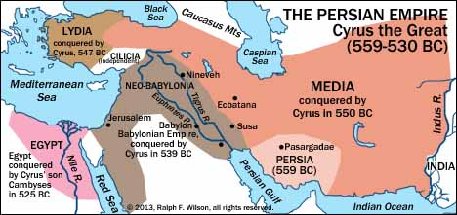

http://www.jesuswalk.com/isaiah/maps.htm

Map below: http://www.jesuswalk.com/isaiah/maps/israel-and-judah-isaiah-1627x2850x300.jpg
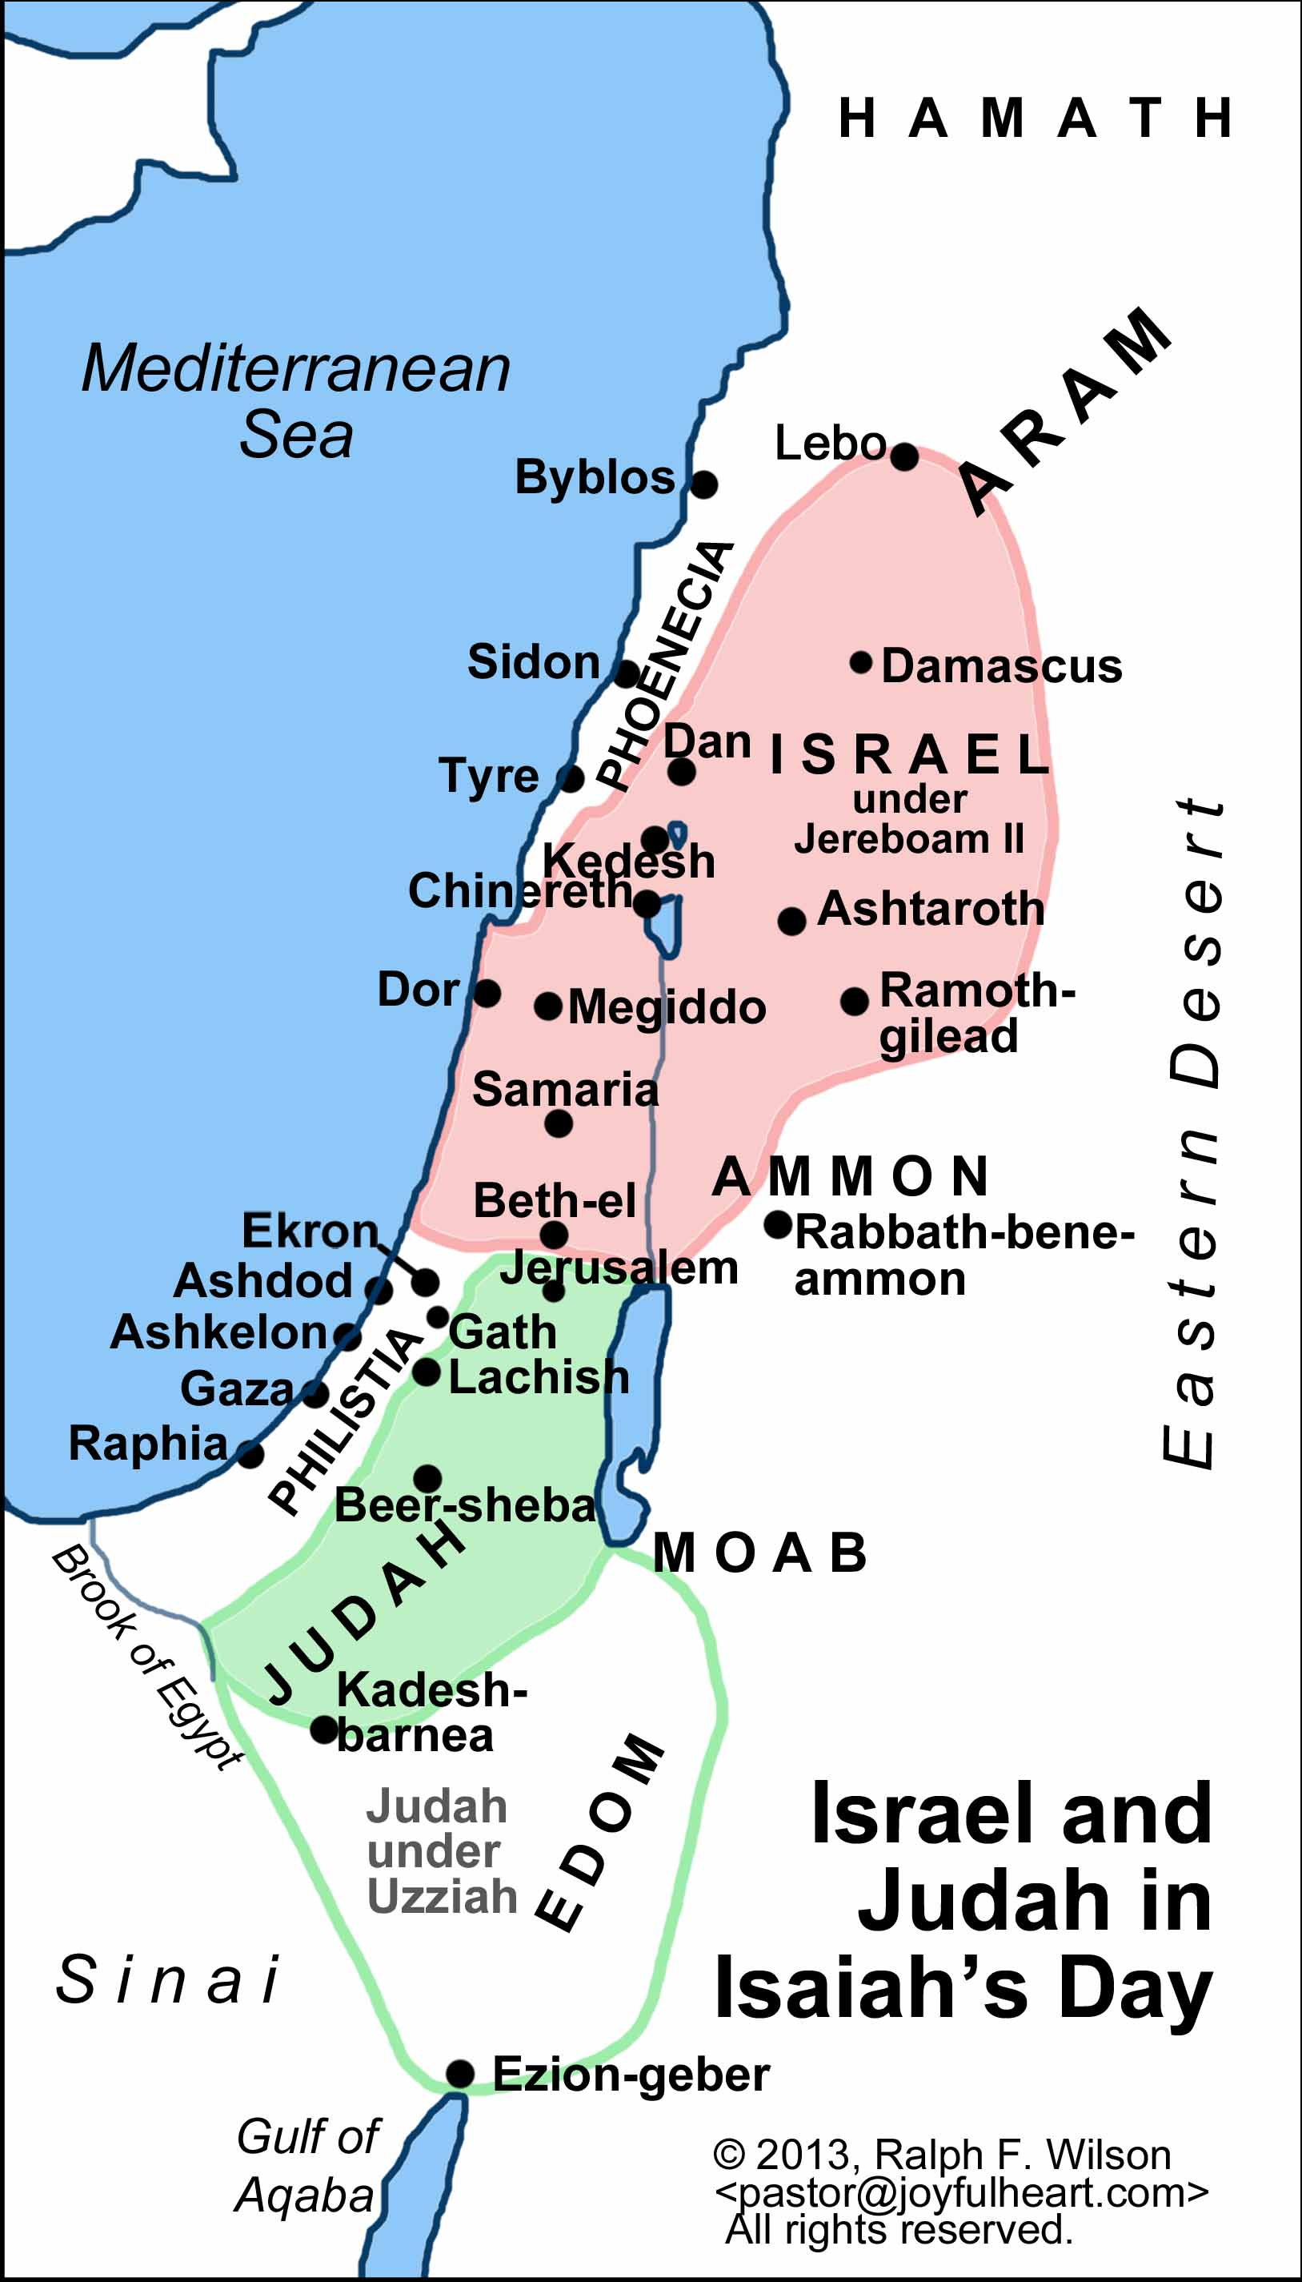
Much of OT history concerns how one after the other of the extreme ends of this fertile crescent became THE power: how the Jews were down in slavery at one end of Egypt, and how God brought them back; how they were taken as slaves to the other end in Babylon and how God brought them back. They were tossed to and fro, and when any empire, like Assyria or Egypt, wanted to become the ‘master race’ of the whole world they had to conquer the rest of the crescent and they would march around to meet the other end – and of course they would have to pass through Israel and Judah, right in the middle.
As well as the two big centres of power at the other end, there were smaller powers: the Philistines, the Moabites, the Edomites, the Syrians, the Phoenicians of Tyre and Sidon.
Assyria, the growing empire of the period, is getting bigger and more powerful and so is going to press down to conquer Egypt to try to control the world. So, the first country she conquered was Syria, then, pressing down, she conquered Israel. At first, she bypassed Judah, conquered the Philistines, and went on for Egypt, but turning back she came to attack Judah with its capital Jerusalem, and it was there that the mighty Assyrian army was defeated.
Something else had happened which lies behind these chapters. Sargon, the mightiest king of Assyria, had died. With his death the little nations he had overrun saw a change to regain their freedom, throwing off the Assyrian bondage. So there was a spate of alliances between the little nations in the middle, against Assyria. For example, Israel and Syria had made an alliance.
We learn that the Philistines, of all people, came to Judah and invited Hezekiah to join with them, and Judah, the people of God, were very much tempted to do this. Isaiah came into that situation and warned against putting trust in alliances with other peoples; the people of God were to put their trust in God.
He prophesied, or predicted the future of other nations in the region, warning that if God’s people put their trust in those nations they were putting their trust in a people who were going to vanish, who would be a broken reed. He mentions Babylon, which was then quite a second rate nation, but Judah was thinking of allying with Babylon against Assyria. He mentions Syria, Tyre and Sidon, the commercial empire of the Phoenicians, Israel, Moab, the Philistine Empire, Edom, the Arabs, Egypt, Ethiopia and the Medes. Of these peoples, one after the other, he warns that if you put your trust in them, know that they are on the way out and you will come to nothing.
The people of God should look to God.

The first one mentioned is the kingdom of Babylon, a rather small nation, south of Assyria, with its capital city, Babylon, on the Euphrates, and it was completely overshadowed by Assyria at that time. Assyria was controlling Babylon. But, when Sargon died, all those other nations thought that, if they could get Babylon with them, Babylon could attack them from one side while they could attack from the other – they had it all worked out.
Judah was considering making an alliance with Babylon, and Isaiah was warning against doing so. Isaiah assumes Babylon is going to become greater and more powerful than Assyria and was going to become the most powerful nation that Israel had ever known. This was long before it happened.
Babylon would become the worst enemy they had ever had. If Assyria attacked Judah and nearly succeeded in taking Jerusalem, Babylon would actually take Jerusalem and take the Jews back as slaves for 70 years.
The next thing Isaiah predicts about Babylon is that is would later collapse and completely disappear. Therefore, to put your trust in Babylon would be wrong for 2 reasons: Isaiah 13:17 predicts the fall of Babylon after it has risen and does so in remarkable detail. There is a graphic picture of the eclipse, the death struggle and the overthrow of Babylon.
Is it not astonishing that, when God says something, it is going to happen! The Medes were those who were called by God to deal with Babylon, as Babylon was called by God to deal with Assyria, as Assyria was called by God to deal with Syria.
God is charge of world history.

You may be interested to know how the Medes took Babylon. That city had a wall around it forty-five miles long (from the top) and two hundred feet high. Cyrus, King of the Medes, dug a canal. Right through the city, with its wall, ran the great river Euphrates, and he diverted the river round the city. The watercourse dried up and he simply marched his army through the dry tunnel into the city of Babylon and it fell in one night. It is the most dramatic story but God gave the idea. SEE: DANIEL 5
One even more interesting thing is that when Alexander the Great from Greece, establishing his empire, marched here, he decided that Babylon would be an ideal place for his eastern capital, and gave orders to rebuild it. He died within weeks, at the age of 30, and Babylon was not rebuilt.
Colossians 1:15-18
“15 He is the image of the invisible God, the firstborn over all creation. 16 For by Him all things were created that are in heaven and that are on earth, visible and invisible, whether thrones or dominions or principalities or powers. All things were created through Him and for Him. 17 And He is before all things, and in Him all things consist. 18 And He is the head of the body, the church, who is the beginning, the firstborn from the dead, that in all things He may have the preeminence.

